LabVolt Transformer Lab
ECEN 390
Seth Ricks
11/14/2025

LabVolt Transformer Lab (50 Points)
(jas, LabVolt Transformer Lab.docx, 8/30/2025)

Note: When working with dangerous high voltages and rotating machinery, work in groups of two or three for safety. Groups larger than three result in some simply observing rather than contributing. Submit an electronic version of a lab report to receive credit for doing this lab. The goal of your lab report is to provide sufficient documentation so that the lab can be repeated if necessary. Therefore, simply add to this document to arrive at your lab report, as all the explanatory text, procedures, and Discussion and Conclusion questions contained in this document are required for a complete lab report. So for your lab report, add a cover page that includes name or names, class and name of the lab. Also add in your results, and answers to the Discussion and Conclusions questions to the existing lab document. While you are to share all Procedure items with any lab partners, your Discussion and Conclusions section is to be uniquely yours. See the grading rubric at the end of this document for more details.

Purpose: The purpose of this lab is to become more familiar with transformers using the LabVolt test bench. The LabVolt main power switch is locked in the off position by a combination lock, with combination 3 1 1, that will need to be removed and then replaced when you are finished with a lab.

Transformers

Electrical transformers utilize a common magnetic core to direct alternating magnetic flux through various windings. Transformers are based on Faraday’s Law, expressed as V_{emf} = -Nd$Φ$/dt, where N is the number of turns in a winding. In a transformer, a changing voltage applied to one winding produces a changing magnetic flux throughout the magnetic core, resulting in induced emfs in all other windings surrounding the core. Since an applied input voltage and resulting induced output voltages are both proportional to the same rate-of-change of magnetic flux, the input and output voltages are in phase. The transformer dot convention indicates which connections to transformer windings have voltages of the same phase. Also, conventional current flowing into a dot on a transformer winding corresponds to in-phase currents flowing out of the dots on other windings.

The voltage induced in a single winding of a common core transformer is the same for all windings that equally coupled to the same core. Hence, in a transformer the induced AC voltage of a given winding is dependent upon the number of turns (coils) and can be made larger or smaller than the applied voltage by incorporating a larger or smaller number of turns. In the following equations, the input winding of a transformer is referred to as the primary with the output winding or windings referred to as secondary windings. For an ideal two-winding transformer, the following equations apply:

$$\frac{V_{p}}{V_{s}}=\frac{N_{p}}{N_{s}}=turns ratio a, and \frac{I_{p}}{I_{s}}=\frac{N_{s}}{N_{p}}=\frac{1}{a}.$$
where V_{s}, I_{s} and N_{s} are the secondary voltage, current and number of turns, and V_{p}, I_{p} and N_{p} are the primary voltage, current and number of turns. So V_{p} = aV_{s} and I_{p} = I_{s}/a, implying that stepping up the voltage from primary to secondary, steps down the current and vice versa.

A transformer is a power conversion device, transforming voltage and currents between windings. For an ideal transformer, $V_{p}I_{p}=V_{s}I_{s}$. The resulting voltage to current ratio at the primary or secondary, which is an impedance, is transformed by the turns ratio squared to the other winding. Hence, a transformer also transforms impedances between windings.
$$Z_{p}=\frac{V_{p}}{I_{p}}=\frac{V_{s}}{I_{s}}\frac{N_{p}}{N_{s}}\frac{N_{p}}{N_{s}}=\frac{V_{s}}{I_{s}}{\left(\frac{N_{p}}{N_{s}}\right)}^{2}. Z_{s}=\frac{V_{s}}{I_{s}}. Z_{p}=Z_{s}{\left(\frac{N_{p}}{N_{s}}\right)}^{2}. Also,Z_{s}=Z_{p}{\left(\frac{N_{s}}{N_{p}}\right)}^{2}.$$
Since power transformers are high efficiency devices, the power rating of the secondary winding is generally considered equal to that of the primary winding. The LabVolt Single-Phase Transformer Unit schematic diagram is illustrated below in Figure 1.
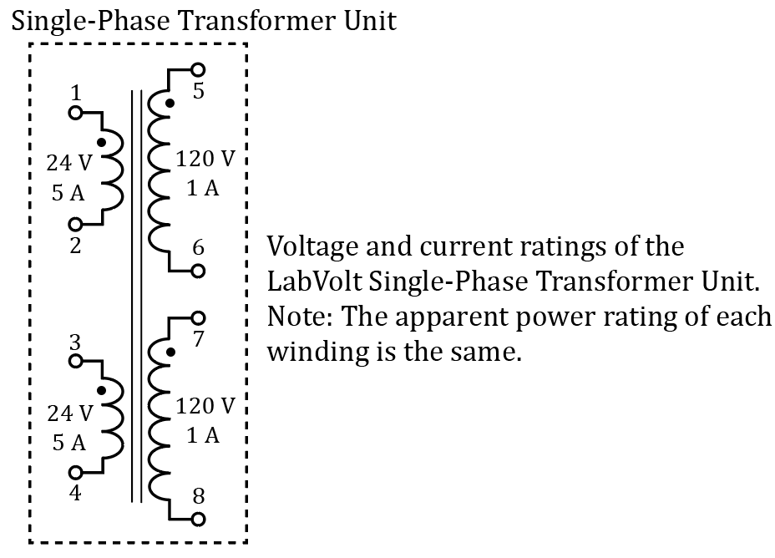
Figure 1: Schematic Diagram of the LabVolt Single-Phase Transformer Unit.

As seen in Figure 1, there are two separate transformers sharing a common magnetic core, corresponding to 4 windings wound on a single core. The transformer windings having the same ratings can be connected in series for a larger rated voltage or in parallel for a larger rated current. Transformers are often rated in terms of Apparent Power, which is the Volt⋅Ampere product in units of Volt⋅Ampere (VA). The apparent power rating of each winding of the transformer shown in Figure 1 equals (24 V)(5 A) = (120 V)(1 A) = 120 VA.

In practical transformers, AC current flows into the primary even with the secondary open circuited. The resulting primary input current for an open-circuited secondary is referred to as the excitation current. The excitation current consists of two components: a core-loss current and a magnetization current. The core-loss current is the additional current required to make up for hysteresis and eddy current power losses in the transformer magnetic core. The magnetization current is the current required to produce the necessary magnetic flux in the transformer core. The core-loss current component corresponds to power losses in the transformer core, while the magnetization current component corresponds to inductive reactance. As will be seen in the following measurements, the primary input current of a transformer is not sinusoidal, even for a sinusoidal primary voltage, because of the non-linear behavior of the transformer core.

Equipment

The following equipment will be used in this lab exercise:

Data Acquisition and Control Interface (DACI) Unit

The Data Acquisition and Control Interface (DACI) is shown in Figure 2. It provides the instrumentation interface between the LabVolt bench and the host computer which runs a virtual instrumentation and control application. The DACI unit has four voltage measurement inputs labeled as E1 through E4, with E corresponding to the measurement of an electromotive force, or emf. The DACI unit also has four current measurement inputs labeled I1 through I4, each offering either a 4 A or 40 A current range. In conjunction with the host software, many various AC or DC measurements can be made by means of the DACI, including voltage, current, power, impedance, phase angle and power factor.

The DACI unit requires a low-voltage power supply for operation. The power input jacks are located at the bottom center of the panel. The jacks are identical and are designed for daisy-chain of multiple units. Make sure that the thin-wire cable is connected between one of these jacks and the similar jacks located on the Power Supply unit. Power must be supplied to the DACI unit before running the Instrumentation and Control application on the lab computer. Turn off the low-voltage power supply switch on the Power Supply unit when a lab is completed.
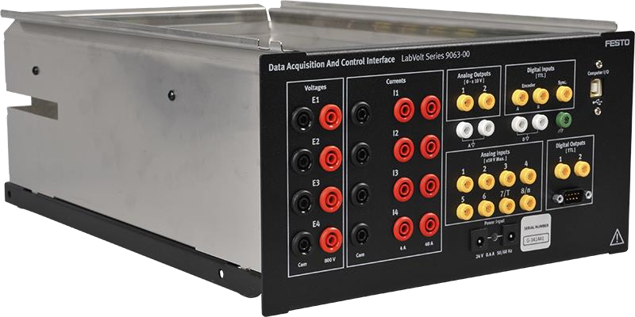
Figure 2: The Data Acquisition and Control Interface Unit.
Referring to Figure 2, the red and black front panel connectors associated with voltages E1 - E4 are the positive and negative voltmeter connections, respectively. For the current meters I1 – I4 shown in Figure 3, the two vertical sets of red front panel input connectors, corresponding to two different range options, 4 A or 40 A. Current meters I1 – I4 measure current by means of internal low-resistance sense resistors that convert current to voltage. Blowable fuses in series with low-resistance sense resistors are included to protect against excessive current flow. A blown fuse in a current measurement channel must be replaced to make a given channel functional. 5 A replacement fuses are available and can safely be replaced by making sure that the main power switch for the Power Supply unit is set to the off position (◯). The fuses can then be accessed and replaced by sliding the Data Acquisition and Control Interface unit partially out of the LabVolt chassis. Simply choose another current meter channel for measurements if no replacement fuses are available.

Resistive Load Unit
CAUTION: Make sure that you do not exceed the maximum current rating associated with each resistor, which will be the case if the applied voltage does not exceed 120 V DC or 120 V rms.
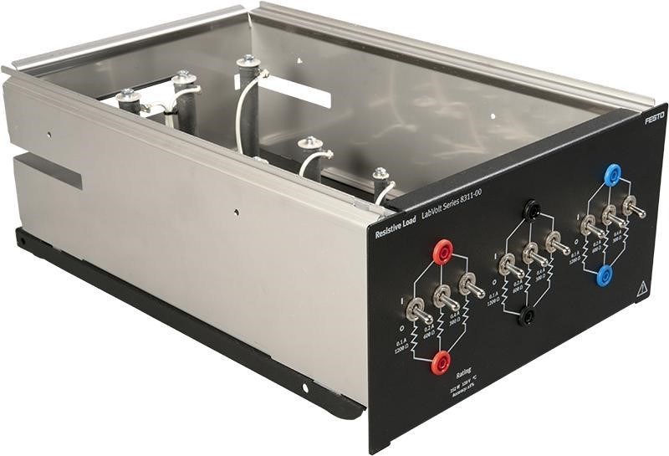
Figure 3: The Resistive Load Unit.

The Resistive Load Unit shown above in Figure 3, provides three banks of three parallel resistors that can be used to provide a balanced three-phase load. The three resistor values on each phase are 300 Ω, 600 Ω, and 1200 Ω. Each resistor is individually switched so that you can create various total resistor values. A switch in the up position inserts the associated resistor between the terminal connectors. Unless otherwise noted, we will create balanced three-phase loads, which means that the switch positions should be identical for all three banks of load resistors.

Single Phase Transformer Unit

The Transformer Unit 8353 consists of a power transformer enclosed in a module. The unit is shown in Figure 4. Both the high-voltage (120 V) and low-voltage (24 V) sides of the Transformer are made of two identical separate windings. Banana jacks on the module front panel provide access to each winding, allowing connection in a variety of configurations. The Transformer has an ideal turns-ratio N_{s}/N_{p} = 1:5, when considering the totality of its primary and secondary windings. The Transformer windings are polarized, and the polarity of each winding is indicated by a small dot on the module front panel. A thermistor output allows monitoring of transformer temperature to prevent overheating. Each high-voltage winding can support up to 1 A of current with a maximum voltage of 120 V AC rms. Each low-voltage winding can support up to 5 A of current with a maximum voltage of 24 V AC rms. Warning: Never let a DC voltage or current be connected to a transformer.
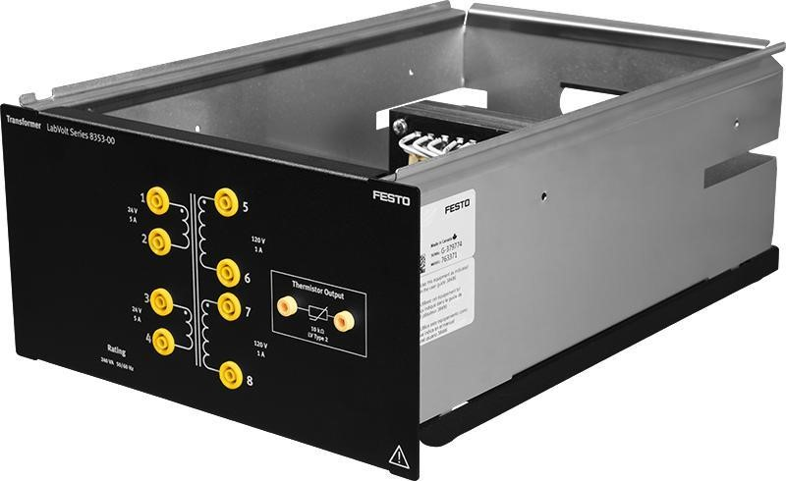
Figure 4: The Single-Phase Transformer Unit.

Power Supply Unit

The power supply unit is shown in Figure 5 and provides electrical power to most of the other LabVolt units. The power supply unit provides high-voltage AC and DC at fixed and variable voltage levels. The power supply unit also provides 24 V DC to power the Data Acquisition and Control Interface Unit (DAC Unit). A brief description of the essential elements of the power supply unit follows:
The main power switch for the Power Supply unit is in the upper left corner of the panel shown in Figure 5. This is the switch that turns on and off the high-voltage AC and DC power supplies. (Note: A | indicates the switch on position with a ◯ indicating the switch off position.) The main power switch is locked in the off position by a padlock that will need to be removed, then replaced when you are finished with a lab. To minimize the high-voltage hazard, keep the main high-voltage power switch of the Power Supply unit in the off position until you are ready to start an experiment, and then turn off this switch as soon as possible at the conclusion of a given experiment.
The auxiliary low-power supply switch is located at the bottom left of the Power Supply unit illustrated in Figure 5, and controls power to the two jacks just to the right of the switch. (Note: A | indicates the switch on position with a ◯ indicating the switch off position.) The auxiliary low-power supply provides power to the Data Acquisition and Control Interface (DACI Unit) by means of a thin power cable connected between the two units. Power must be supplied to the DACI Unit before running the Instrumentation and Control application on the lab computer. Hence, the auxiliary low-power supply is to be turned on at the start of each lab and left on until the lab is completed. Whereas the main power switch for the high-voltage supplies should be turned off whenever the high-voltage of those supplies is not required, such as when wiring up specific circuits.

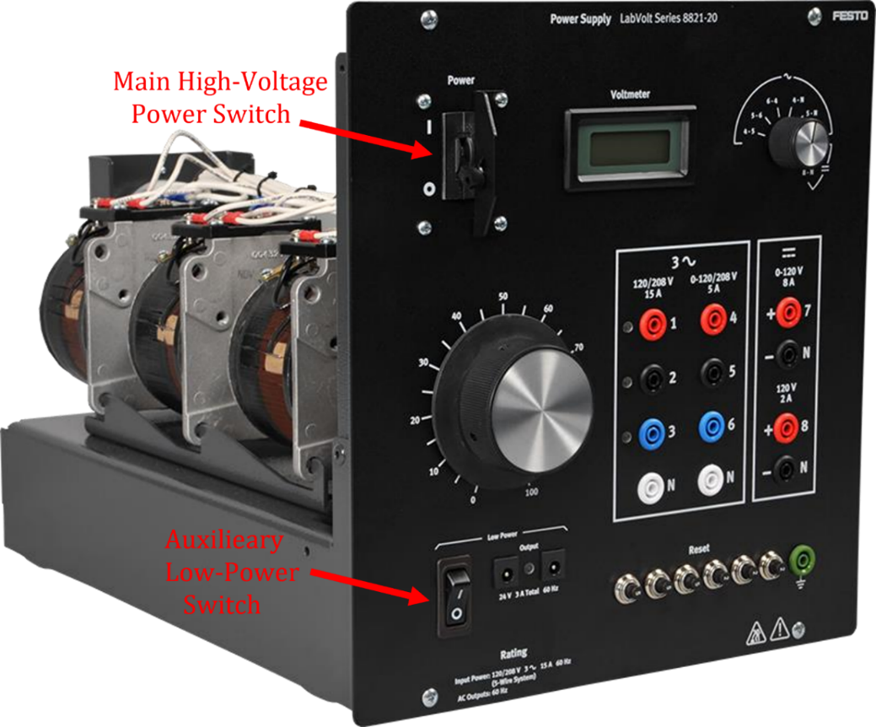
Figure 5: The LabVolt Power Supply Unit for providing fixed and variable AC and DC voltages.
The LabVolt power supply illustrated in Figure 5 provides both fixed and adjustable AC and DC output voltages. The left most column of front panel connectors labeled 120/208 V 15 A, provide a fixed 4-wire three-phase Wye (Y) connected source, with outputs labeled 1, 2, 3 and a neutral N. The middle column of front panel connectors labeled 120/208 V 5 A, provide an adjustable 4-wire three-phase Wye (Y) connected source, with outputs labeled 4, 5, 6 and a neutral N.
The large dial with an adjustment scale ranging from 0 to 100%, provides the adjustment for the AC and DC adjustable output voltages. The right most column of front panel connectors with the upper two connectors labeled 7 and N is an adjustable DC output voltage, while the lower two DC connectors in the right most DC output column labeled 8 and N provide a fixed DC output voltage as indicated.
The LCD voltmeter illustrated in Figure 5 works in conjunction with the selector switch to the right of the LCD display. The selector switch is to be rotated to the desired output voltage for display, with possible options being AC line-to-line voltages V₄₅ or V₅₆, or V₆₄, or AC phase voltages V_{4N} or V_{5N} or V_{6N}, or DC voltages V_{7N} or V_{8N}, with N referring to the Neutral side of the voltages.

With the main power switch of the Power Supply unit turned on, the voltages at the connectors labeled 4, 5, 6, i.e., V_{4N}, V_{5N}, and V_{6N}, are the corresponding adjustable phase voltages with respect to the Neutral N of an adjustable three-phase Wye (Y) connected source. For this lab, the single adjustable AC phase voltage V_{4N} is used to power a transformer. So, the selector switch associated with the LCD display is to be set to 4-N to display the rms phase voltage V_{4N}.

Several resettable overcurrent circuit breakers are located at the lower right of the panel. If your lab circuit is not receiving power, first check your connections, and then check for tripped overcurrent breakers, pushing in the button of a tripped breaker to reengage the power to the circuits.

Procedure:
WARNING: High voltages are present in this laboratory exercise. Do not make or modify safety banana jack wiring with the Main High Voltage Power Switch for the Power Supply Unit on.
Part 1 – Open-Circuit Transformer

- Connect the circuit shown below in Figure 6 for unloaded testing of the LabVolt Single-Phase Transformer Unit. Ammeter I2 is included for the next part of the lab. (Note: Jumper wire colors and LabVolt unit locations shown below in Figure 6(b) are only examples and not necessarily what you will encounter.)
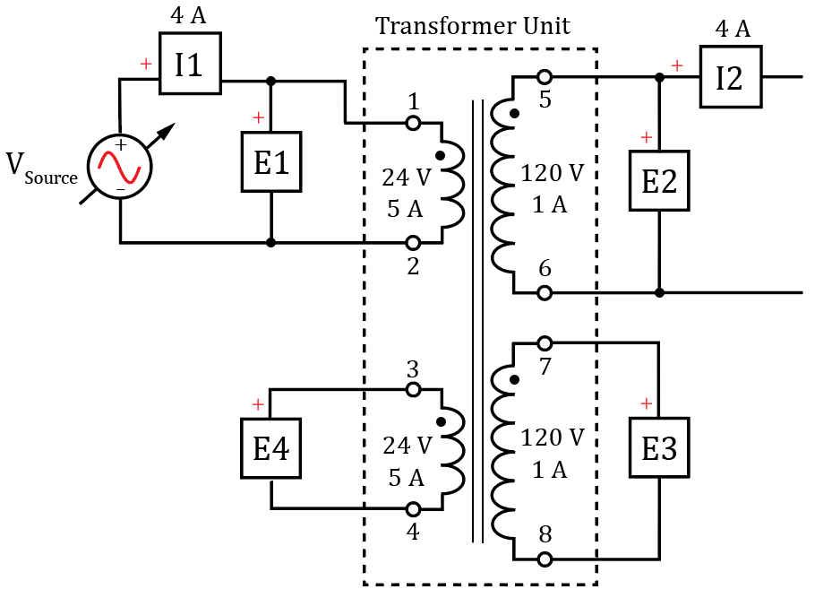
(a) Schematic Diagram for Unloaded Single-Phase Transformer Measurements.
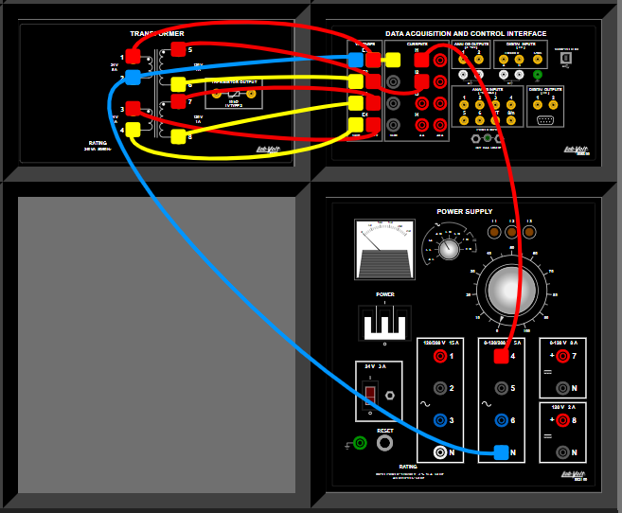
(b) Wiring diagram for Unloaded Single-Phase Transformer Measurements.

Figure 6: (a) Schematic Diagram for Unloaded Single-Phase Transformer Measurements. (b) Wiring diagram for Unloaded Single-Phase Transformer Measurements.

- Make sure that the USB port of the Data Acquisition and Control Interface (DACI) unit are connected to USB ports on the host computer.
- Turn on the auxiliary low-power supply on the Power Supply Unit, to power the Data Acquisition and Control Interface (DACI) unit.
- Turn the host computer on and then start the LVDAC-EMS software.
In the Module Selector window, make sure that the Data Acquisition and Control Interface (DACI) and the Four-Quadrant Dynamometer/Power Supply are detected. Choose 120 V – 60 Hz for the Local Network Voltage and Frequency and then click the OK button to close the LVDAC-EMS Start-Up window.
- In the LVDAC-EMS application, select Instruments Metering, and set up the meters to measure AC voltages and currents as follows referring to Figure 6: Configure meter M1 to measure the AC voltage E1 and meter M2 to measure AC current I1 using the default 4 A input range. Then configure meter M3 to measure the AC voltage E2 and meter M4 to measure AC current I2 using the default 4 A input range. Then configure meter M5 to measure the AC voltage E3 and meter M6 to measure AC voltage E4.
- On the LabVolt Power Supply unit, set the LCD voltmeter selector switch to select 4⋅N corresponding to the adjustable AC phase voltage V_{4N}. Then rotate the large Variable Control knob to 0 for an initially 0 V rms AC output on V_{4N.}
- Turn on the main power switch of the LabVolt Power Supply unit.
- Then adjust the AC voltage V_{4N} to equal 20 V rms.
- In the Oscilloscope window, Configure Channel1 to display E1 with a vertical scale of 50 V/div, Channel 2 to display I1 with a vertical scale of 0.5 A/div, Channel 3 to display E2 with a vertical scale of 50 V/div, Channel 4 to display E3 with a vertical scale of 50 V/div and Channel 5 to display E4 with a vertical scale of 50 V/div.
- Verify that the oscilloscope time base is 5 ms/div.
- The 0 V level of each oscilloscope trace is indicated by the markers on the left-hand side of the window. With the cursor initially spread out the 0 V reference marker for traces 1-5, then adjust the markers for a small offset between the Channel 1 and Channel 5 traces and the Channel 3 and Channel 4 traces so that both traces can be seen, as shown below in Figure 6.
- Verify that the values displayed in the Oscilloscope window seem reasonable for the applied V_{source} value. (Note: Your E1 measured value may be somewhat different than the 24 V rms for V_{source} because the accuracy of the Power Supply Unit LCD display is not as good as the accuracy of the DACI Unit measurements.)
- Select View Color Settings in the Oscilloscope window to change the assigned colors for at least one of the five displayed traces so that your oscilloscope plot has at least one trace a different color than Figure 6 below. (Note: For the LVDAC-EMS oscilloscope, LA stands for Last Acquisition.)
- Replace Figure 6 below with a screen shot of your Oscilloscope window, including the channel measured values below the waveforms, along with the Oscilloscope settings to the right of the waveforms. Be sure to assign at least one different color to the five displayed traces than those used below in Figure 6. Replace the Figure below with your version. (7 Points.)
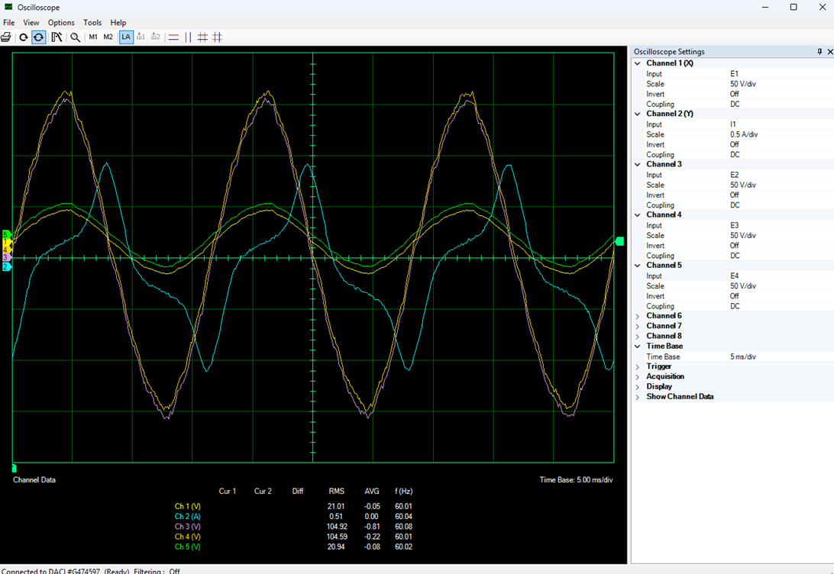
Figure 6: Oscilloscope Screen Capture of Unloaded Single-Phase Transformer Measurements.

- Turn off the main power switch of the LabVolt Power Supply unit.
- Based on your Oscilloscope screen shot in Figure 6, determine the turns ratio to three significant digits between each of the following windings with respect to the winding connected between terminals 1 and 2. The winding connected between terminals 5 and 6 is denoted as N₅₋₆, and the winding connected between terminals 1 and 2 is denoted as N₁₋₂. (6 points.)

N₅₋₆/N₁₋₂: 4.994 (2 points.)

N₇₋₈/N₁₋₂: 4.978 (2 points.)

N₃₋₄/N₁₋₂: 0.997 (2 points.)

Part 2 – Step-Up Transformer

- Connect the circuit shown below in Figure 7 for testing of a step-up transformer. Set the switches in the resistive load unit all in the down position resulting in R_{load} = ∞ Ω. (Note: Jumper wire colors and LabVolt unit locations shown below in Figure 7(b) are only examples and not necessarily what you will encounter.)
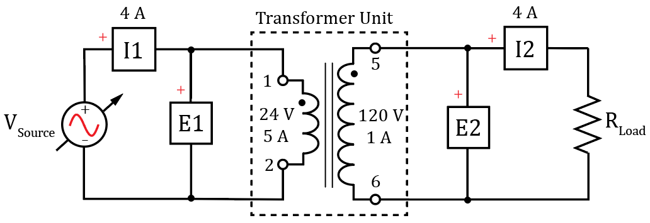
(a) Schematic Diagram for the Step-up Transformer with a Load.

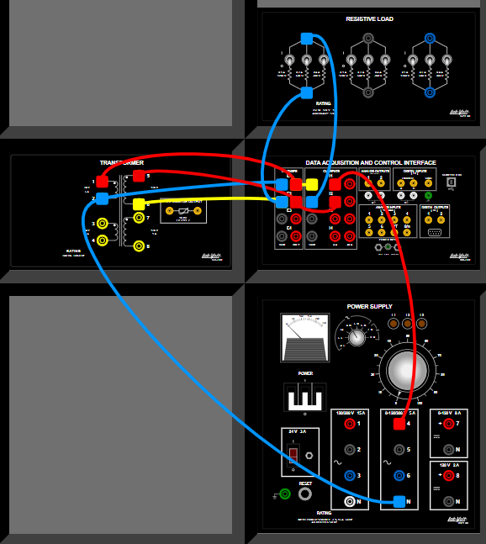
(b) Wiring diagram for the Step-up Transformer with a Load.

Figure 7: (a) Schematic Diagram for the Step-up Transformer with a Load. (b) Wiring diagram for the Step-up Transformer with a Load.

- In the LVDAC-EMS application, select Instruments Metering, and set up the meters to measure AC voltages and currents and active power as follows: Configure meter M1 to measure the AC voltage E1 and meter M2 to measure AC current I1 using the default 4 A input range. Then configure meter M3 to measure the power corresponding to E1 and I1, selecting the PQS1(E1,I1) measurement function associated with E1 and I1. The PQS1() function provides for measurements of active power (P), reactive power (Q) or apparent power (S), depending on the operating Mode selected in the Meter Settings window. Set the power measurement Mode to P for active power for the PQS1(E1,I1) function, which utilizes the product of E1(t) and I1(t), along with the associated power factor to determine active power. Configure meter M4 to measure the AC voltage E2 and meter M5 to measure AC current I2 using the default 4 A input range. Then configure meter M6 to measure the power corresponding to E2 and I2, selecting the PQS1(E2,I2) measurement function with the measurement Mode set to P for active power associated with E2 and I2. Next configure meter M7 to measure Efficiency P2/P1, which provides the power efficiency of output power P2 with respect to input power P1, returning the result in percent.
- Turn on the main power switch of the LabVolt Power Supply unit and adjust the AC voltage V_{4N} to equal 20 V rms, referred to as V_{source} in Figure 7(a).
- The LVDAC-EMS Data Table and Record Data feature streamlines the process of gathering data from the various LabVolt units and is the recommended method of gathering the data when several measured values are to be recorded.
- In LVDAC-EMS application select Tools Data Table which opens a table that allows the automatic recording of various LabVolt instrument values.
- Next select Options Record Settings Settings Metering to bring up a list of available meter measurements for recording into the Data Table. Then select Options Record Settings Settings Metering to bring up a list of available measurements for recording into the Data Table, as illustrated below in Figure 8. Check the boxes corresponding to the appropriate meters including E1, I1 PQS1(E1, I1), E2, I2, and PQS1(E2, I2).
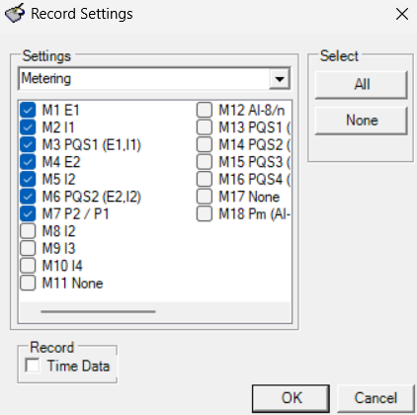
Figure 8: LVDAC-EMS Record Settings Window for Inclusion in a Data Table.

- Your resulting Data Table is now set up for measurement recording and should look like the one illustrated below in Figure 9.
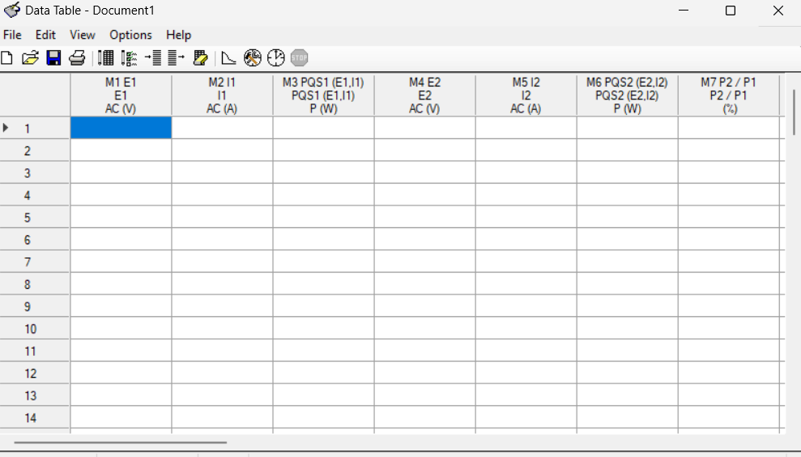
Figure 9: LVDAC-EMS Data Table Window for Step-Up Transformer Measurements.

- Verify that the values displayed in the metering window seem reasonable for the applied V_{source} value. (Note: Your E1 measured value may be somewhat different than the 20 V rms for V_{source} because the accuracy of the Power Supply Unit LCD display is not nearly as good as the accuracy of the DACI Unit measurements.)
- Select Edit Record Data, to record the data associated with the applied V_{source} value. (Note: The row location marker will automatically be advanced to the next row number by the Record Data command.)
- Repeat steps 8 – 9 above with load resistance values of 1200 Ω, 600 Ω, 300 Ω and 171 Ω, where 171 Ω is achieved by paralleling a 1200 Ω, 600 Ω and 300 Ω resistor. The V_{source} value will decrease with increasing load current because of non-negligible source resistance. Adjust V_{source} to 20 V rms on the Power Supply Unit LCD display as needed for the various resistive loads.
- Transfer your recorded data in the LVDAC-EMS software Data Table to Table 1 below.
- While there may be better approaches to getting the data from the LVDAC-EMS software Data Table into Microsoft Word for your lab report, the following approach works. In the LVDAC-EMS software Data Table, select File Export Save as type Comma-Separated Values Files (*.csv), which is a file that can be opened by Microsoft Excel. In Excel, highlight and copy the desired data cells, to be pasted into Microsoft Word. In Word, select a blank location, not in a table, in your document and chose Paste Paste Options Use Destination Styles (S), which creates a table of the desired data. The desired data in this new table can then be copied and pasted into the desired empty cells of Table 1 below by choosing Paste Paste Options Overwrite Cells (O).
- Based on your measured Table 1 data, calculate the magnitude of the input impedance Z1 and along with the magnitude of the output impedance Z2 for each R_{load} value, including your calculated values in the appropriate columns of Table 1.

Table 1: Step-Up Transformer Data for V_{source} = 20 V @ 60 Hz. (18 points.)
R_{load} (Ω) | E1  (V) | I1  (A) | P1  (W) | ∣Z1∣ (Ω) | E2  (V) | I2  (A) | P2  (W) | Efficiency  P2/P1  (%) | ∣Z2∣ (Ω)
∞ | 21.42 | 0.553 | 4.872 | 38.73418 | 106.9 | 0.008 | 0.164 | 3.368 | 13362.5
1200 Ω | 20.57 | 0.756 | 13.03 | 27.20899 | 101.9 | 0.088 | 8.904 | 68.31 | 1157.955
600 Ω | 21.16 | 1.126 | 21.74 | 18.79218 | 104.2 | 0.164 | 17.08 | 78.56 | 635.3659
300 Ω | 20.77 | 1.954 | 39.65 | 10.62948 | 100.8 | 0.342 | 34.52 | 87.07 | 294.7368
171 Ω | 20.37 | 3.026 | 61.15 | 6.731659 | 97.05 | 0.563 | 54.67 | 89.4 | 172.3801

- Next you are to import your data into MATLAB for efficiency calculations and plotting results as shown below in Figure 10.
- Plot the transformer efficiency in % versus load current I2. Include an x-axis label of “Load Current (A)” using the xlabel() function. Include a y-axis label of “Efficiency %” using the ylabel() function. (See MATLAB help on “subscripts in Axis labels”, on the xlabel() function to see how to incorporate subscripts.) Also add a title of “Transformer Efficiency versus Load Current – Your Name”. For the efficiency trace include markers for each data point in your plot (Search for plot, i.e., 2-D line plot, and then scroll down to Marker to see how to include data point markers in your MATLAB plot.)
- Replace Figure 10 below with your version. (6 Points.)
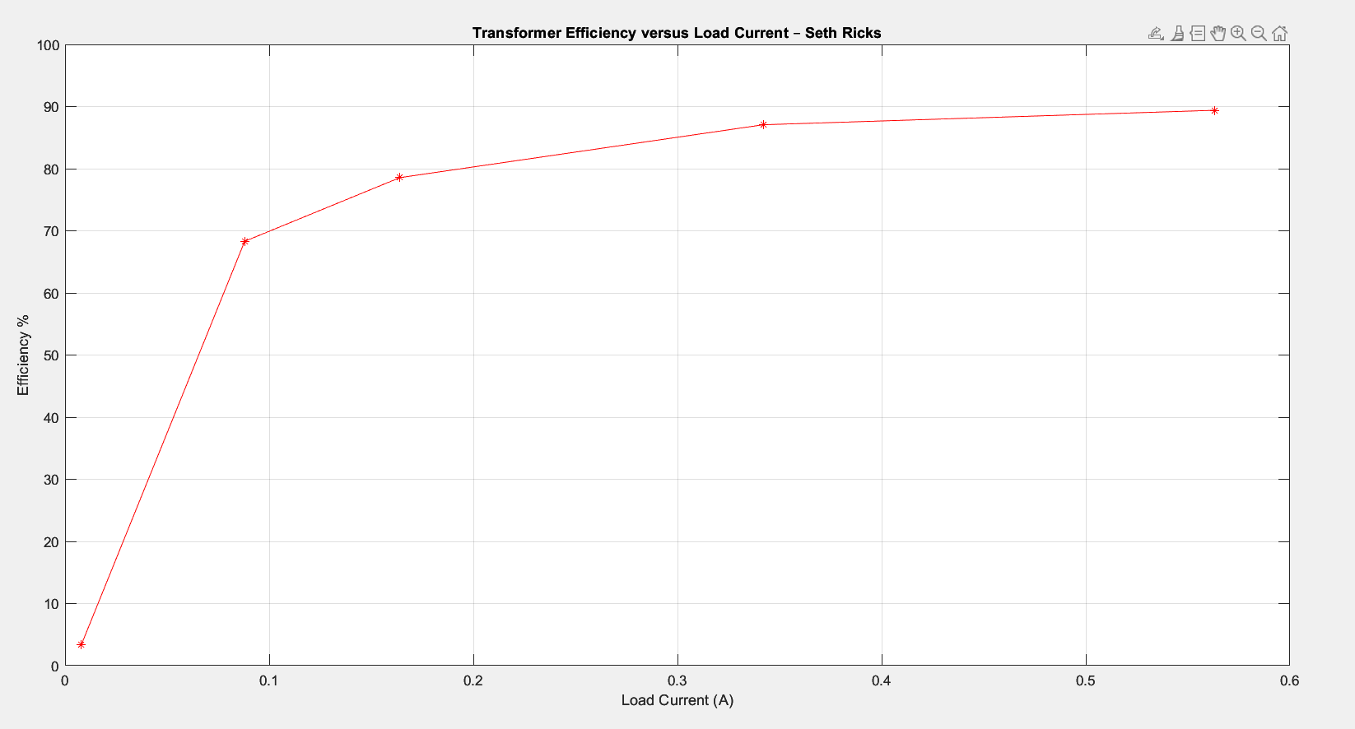
Figure 10: LabVolt Transformer Efficiency versus Load Current.

Discussion and Conclusions Questions: (Note: For the following questions use your own words along with complete sentences. Points are to be deducted for AI generated answers.)

- What is the magnitude of the excitation current in an ideal transformer? (1 point.)

The excitation current in an ideal transformer is ideally 0. Ideally it wouldn’t need any current to magnetize the core.

- Why does transformer efficiency increase with increasing load current as illustrated in Figure 10? (2 points.)

As the load current increases, so does the power to the load. This means that the ratio of power loss will be lower, and thus the efficiency will increase.

- Determine the apparent power rating of the Transformer circuit of Figure 1 if the winding between terminals 1 & 2, is series connected to the winding between terminals 3 & 4, and the winding between terminals 5 & 6, is series connected to the winding between terminals 7 & 8, including units? (1 point.)
(24 V + 24 V) * 5A = 240 VA
(120 V + 120 V) * 1A = 240 VA
240 VA

- Determine the apparent power rating of the Transformer circuit of Figure 1 if the winding between terminals 1 & 2, is parallel connected to the winding between terminals 3 & 4, and the winding between terminals 5 & 6, is series connected to the winding between terminals 7 & 8, including units? (1 point.)
(24V)(5 + 5 A ) = 240 VA
(120V)(1 + 1 A) = 240 VA
240 VA

- Using at least three complete sentences, describe three useful things that can be accomplished with an electrical transformer. (3 points.)
Voltage can be stepped up or stepped down. Current can be stepped down, so that it doesn’t burn up the wire over long distances. We can also do impedance matching, because the load looks like a different impedance to the source.

LabVolt Transformer Ratings Lab Grading Rubric: You can work in groups of up to three if desired for this hardware lab. Teams that have four or more persons make working with the equipment difficult. Submit an electronic version of a lab report to receive credit for doing this lab. The goal of your lab report is to provide sufficient documentation so that the lab can be repeated if necessary. Therefore, simply add to this document to arrive at your lab report, as all the explanatory text, procedures, and Discussion and Conclusion questions contained in this document are required for a complete lab report. So for your lab report, add a cover page that includes the name or names, class and name of the lab. Also add in your results, and answers to the Discussion and Conclusions questions to the existing lab document. While you are to share all Procedure items with any lab partners, your Discussion and Conclusions section is to be uniquely yours.
Lab Report Item | Points
Cover Page | 2
Part 1 - Open-Circuit Transformer  Figure 6: (7 points total. 0.5 points for each reasonable measured value.)  N₅₋₆/N₁₋₂: (2 points.)  N₇₋₈/N₁₋₂: (2 points.)  N₃₋₄/N₁₋₂: (2 points.) | 13
Part 2 - Step-Up Transformer  Table 1: (18 points total.)  Figure 10: (6 points total.) | 24
Discussion and Conclusions | 8
Grammar and Professionalism | 3
Total | 50
Please give feedback on errors you find in this document.

